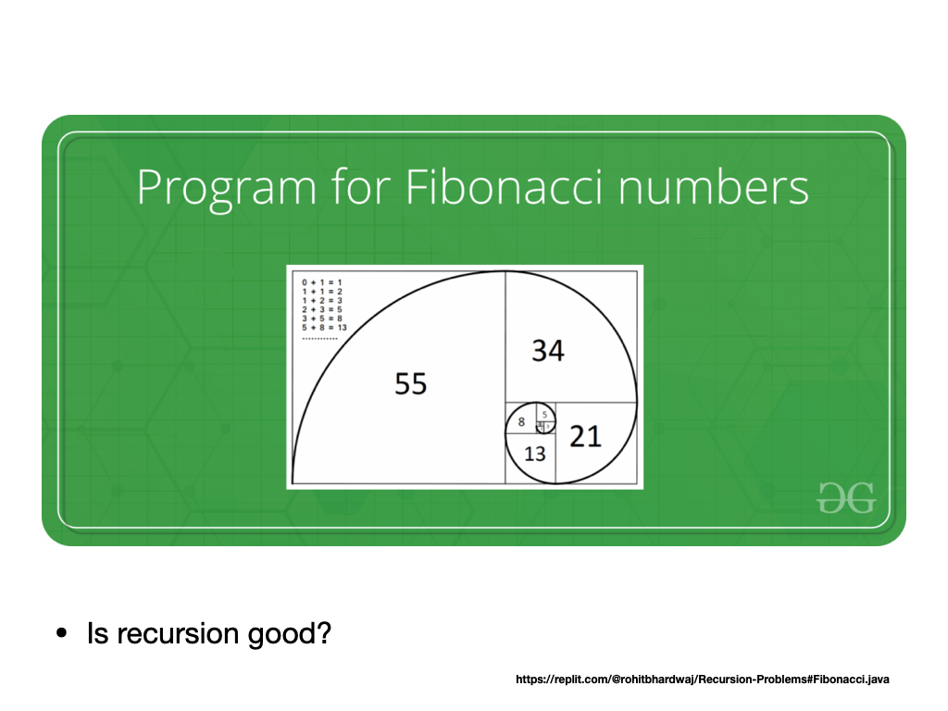

**https://replit.com/@rohitbhardwaj/Recursion-Problems#Fibonacci.java**

**https://replit.com/@rohitbhardwaj/Dynamic-Programming-Problems#DynamicFibonacci.java**